3218 JH
DC axial compact fan
Ebm-papst
Nominal data
Type
3218 JH
VDC
VDC
min-1
W
°C
°C
m3/h
B
dB(A)
48
36 .. 53
6800
9.5
-20
70
146
6.4
55
Nominal voltage
Nominal voltage range
Speed
Power input
Min. ambient temperature
Max. ambient temperature
Air flow
Sound power level
Sound pressure level
ml = max. load · me = max. efficiency · rfa = running at free air · cs = customer specs · cu = customer unit
Subject to alterations
Web data sheet D · Page 1 of 4
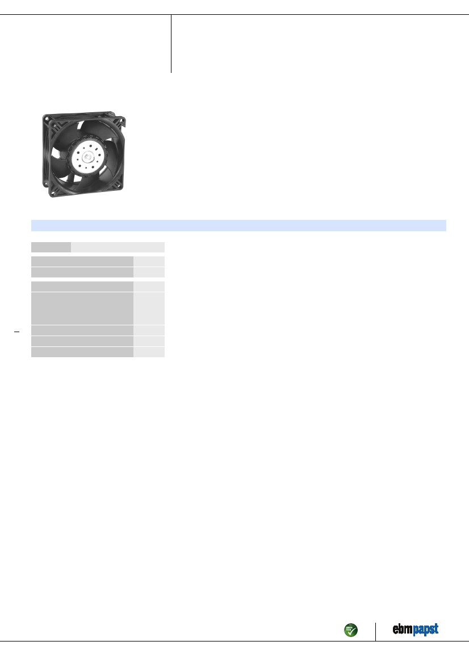
ebm-paps
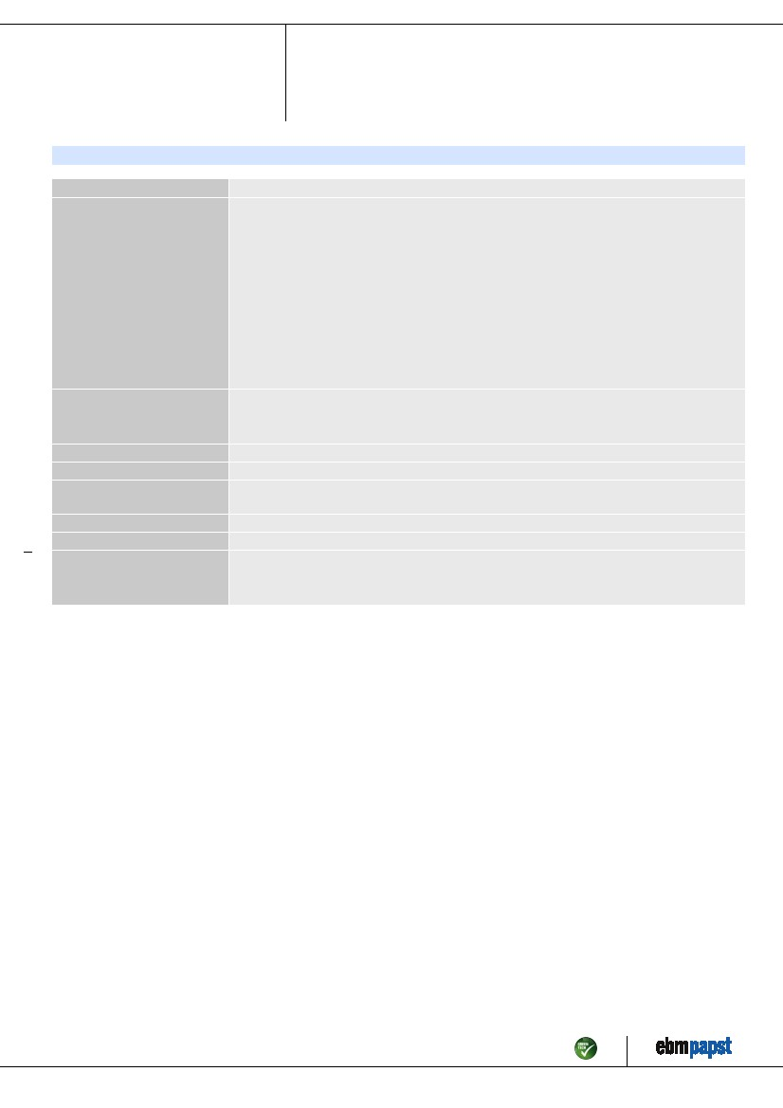
3218 JH
DC axial compact fan
Technical features
Dimensions
General description
92 x 92 x 38 mm
Particular design features:
Rigid compression curve for high air flow at high counterpressure.
Innovative impeller with winglets for low noise.
Optional Vario-Pro: Highly flexible software configuration for the fan ensures an easily customisable
solution to meet the individual requirements of your application.
General features:
Material: fibreglass-reinforced plastic. Impeller PA, housing PBT.
Electronic commutation completely integrated.
Protected against reverse polarity and locking.
Connection via single strands AWG 24 (H3 and H4: AWG 22), TR 64, bared and tin-plated.
Air exhaust over bars. Rotational direction clockwise looking at rotor.
Mass: 240 g (H3 and H4: 280 g).
Single strands AWG 24, TR 64, bared and tin-plated.
Right, looking at rotor
Air exhaust over bars
Ball bearings
70000 h
35000 h
0.240 kg
Fiberglass-reinforced PBT plastic
Fiberglass-reinforced PA plastic
Protected against reverse polarity and locking.
VDE, CSA, UL
Connection line
Direction of rotation
Direction of air flow
Bearing
Lifetime L10 at 40 °C
Lifetime L10 at maximum
temperature
Mass
Housing material
Material of impeller
Motor protection
Approval
Web data sheet D · Page 2 of 4
ebm-papst

3218 JH
DC axial compact fan
Product drawing
Web data sheet D · Page 3 of 4
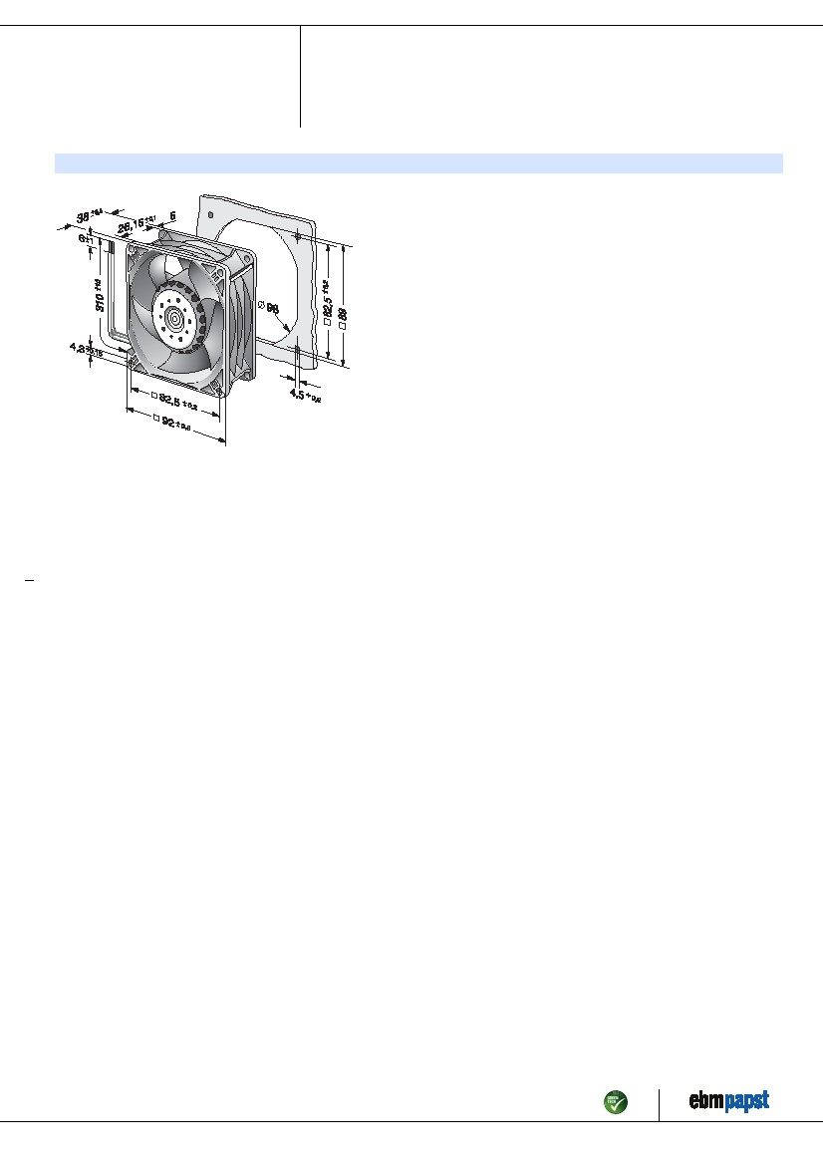
ebm-papst
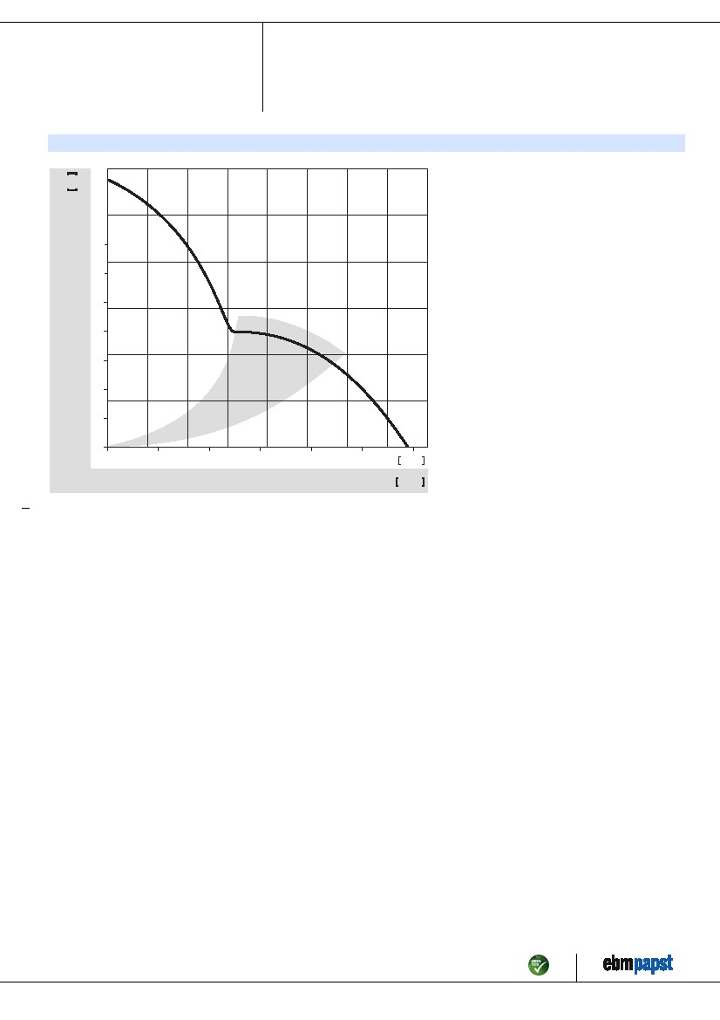
3218 JH
DC axial compact fan
Charts: Air flow
(in H ² O)
0,1
0,3
0,5
0,7
200
160
120
80
40
pf S
Pa
0
15
30
45
60
75
CFM
m³/h
VS
•
20
40
60
80
100
120
Web data sheet D · Page 4 of 4
ebm-papst S

